FAQ

Questions regarding the Excel sheet:
- Our new members don’t have “Member Numbers” yet, where can they get it first? TMI? – After the club is chartered.
- What is “Organization/In care of”? – Leave blank.
- What should they fill out in fields: “New member fees” “Membership Dues”? -$20 new membership fee, $60 for six months
- Should I collect all members’ info in this Excel and send it back to you? -Consolidate members’ info in this Excel spreadsheet.
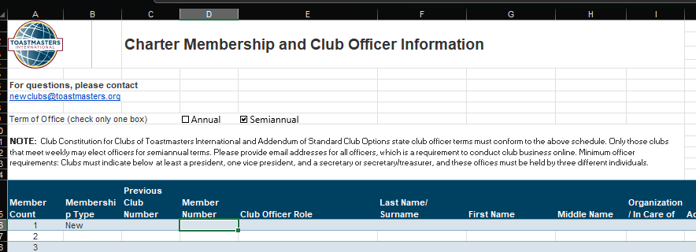

Questions regarding <ato-1-app-to-organize-ff>:
- Should we leave one of the officers Phone# as the club contact? Same as email? - President
- Whose credit card should we use to pay the club charter fee of $125?– Contact HR of your company or use your personal credit card

Questions regarding <ato-5-club-information_2021>:
- Do we have a club# yet? How will it be assigned? -assigned after the club is chartered.

